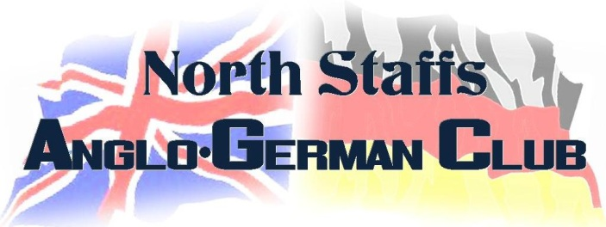
Chairperson: Petra Cox. 01782 341218
Treasurer: Marj Vernon. 01782 922165
13 Berwick Walks, Newcastle-under-Lyme ST5 2LJ

Membership Application

We are very pleased to welcome you to the North Staffs Anglo-German Club.

To ensure we have the correct contact details for you, please fill in this form
and return it with payment to the Treasurer or to the above address.

All details will be kept in a secure database with access restricted to authorised officers only.

We will also use this information to ensure that you are kept informed about club events.

Applicant Information

Name

Address

Postcode

Home telephone number Mobile

Email

Date of Birth

Membership Options

Member Fee Please tick

Full Adult £18.00

OAP £12.00

Student £12.00

Please make cheques payable to North Staffs Anglo-German Club. You can also make a bank transfer into our account at Lloyds TSB. Sort Code: 77-58-02, Acc. No: 33 94 51 68.

Additional Information

Information in this section is optional and will be used for development purposes only.

Would you be prepared to become a volunteer helper at our club? YES NO

What skills do you have that could help develop the North Staffs Anglo-German Club
(e.g. web design, accounting, printing)?

Please let us know any comments or questions that you might have.

Signature

Date Signature

Please download, print and send your completed membership application by post to the above address or scan and send via email to: marjvernon@yahoo.co.uk .

